Civil war in Rwanda

UNSC Resolution: | 893
Date of adoption: | 6 January 1994
Operative paragraph: | 2
Demand number: | 893.0211

Carla Winston

Wording of demand

Cooperate fully in furthering the peace process, comply fully with the Arusha Peace Agreement, on which the schedule contained in the report of 24 September 1993 is based, and in particular establish a broad-based transitional government at the earliest opportunity in accordance with this Agreement

List of addressees of the demand

Rwandan Patriotic Front, Government of Rwanda

Short-term compliance

Description of the addressee(s)’ conduct

10. While various Rwandese political leaders have also recognized the urgent need to establish the broad-based transitional Government and the Transitional National Assembly in order to ensure the smooth and orderly functioning of the country, they nevertheless remain deadlocked on the modalities for putting those institutions in place. My Special Representative and I have stressed to the Rwandese political leaders that, without the early establishment of the broad-based transitional Government and the Transitional National Assembly, it would be difficult to affirm that sufficient progress has been made in the implementation of the Arusha peace agreement to warrant the continued support of the international community.

12. Following a series of all-party consultations that my Special Representative organized at UNAMIR headquarters in Kigali on 7, 10 and 13 February, broad consensus was reached among the various political leaders to set up the transitional institutions on 14 February, while giving the Liberal Party more time to resolve its internal problems and to join those institutions later and leaving the courts to decide on the factional rift within the Democratic Republican Movement. However, reservations to the consensus were expressed by the Mouvement républicain national pour le développement et la démocratie (Republican National Movement for Development and Democracy) and by other elements close to the President, who argued that all outstanding problems should first be resolved before proceeding to set up the broad-based transitional Government and the Transitional National Assembly, so that all political parties concerned could participate in those institutions from the outset. Nevertheless, the key element in that consensus, which provides for the installation of the broad-based transitional Government and the Transitional National Assembly even if some political parties are not in a position to participate immediately, has continued to feature in the discussions among the Rwandese political leaders.

13. An agreement reached at meetings of the political parties on 16 and 18 February to establish the transitional institutions on 22 February was set back as a result of the sudden outbreak of violence in Kigali and in other regions of the country beginning on 21 February. This resurgence of violence, in the course of which two prominent political leaders, Mr. Félicien Gatabazi, the Minister of Public Works and Energy who was also the Secretary-General of the Parti social démocrate (Social Democrat Party), and Mr. Martin Buchyana, the President of the Coalition pour la défense de la république (Coalition for the Defence of the Republic), were murdered, an RPF soldier killed and a UNAMIR military observer wounded in an ambush, contributed to heightening tension and worsening the overall political climate. On 23 February, another effort to install the transitional institutions also failed when the ceremony organized for that purpose by President Habyarimana was boycotted by most political parties, including RPF, which in a press release issued on the same day accused the President of trying to impose a unilateral solution to the internal problems within the Liberal Party and the Democratic Republican Movement.

15. Following meetings held on 25 and 27 February at the initiative of the President, the five political parties represented in the current coalition Government indicated in a communiqué dated 27 February that agreement had been reached on a formula to resolve the internal problems within the Democratic Republican Movement but that a consensus had still not been reached on the rift within the Liberal Party owing to the reservations expressed by one of the leaders of that party. Following the announcement of the RPF’s rejection of the proposed compromise in a communiqué dated 28 February.

46. As the implementation process commenced, there was a general expectation that the new institutions would be installed by 5 January 1994 to guide Rwanda through a two-year transitional period. Thus far, only one of those institutions, the Presidency, which was officially installed on the target date of 5 January, has been put in place.
Failure to establish the broad-based transitional Government and the
Transitional National Assembly has continued to impede the implementation of the other provisions of the agreement.
(SECOND PROGRESS REPORT OF THE SECRETARY-GENERAL ON THE UNITED NATIONS ASSISTANCE MISSION FOR RWANDA, UN Doc. S/1994/360, of 30 March 1994, par. 10-15, 46)

3. Reliable reports strongly indicate that the killings were started by unruly members of the Presidential Guard, then spread quickly throughout the city. Despite the best efforts of UNAMIR, the Rwandese Patriotic Front (RPF) security battalion quartered at the National Development Council complex broke out and started to engage Government troops, including elements of the Presidential Guard. RPF units from the demilitarized zone also moved towards Kigali and joined the fighting. Authority collapsed, the provisional Government disintegrated and some of its members were killed in the violence. An interim Government was proclaimed on 8 April 1994, but could not establish authority, and on 12 April 1994, as fighting between the armed forces and the RPF intensified, left the capital. Since then, the Defence Minister and the high command of the Rwandese Government Forces (RGF), whose leadership has recently changed, appear to be the only interlocutors available on the Government side. The brutal murders by unruly RGF soldiers of the Prime Minister, Mrs. Agathe Uwilingiyimana, of other members of the Government and of 10 members of the Belgian contingent serving with UNAMIR were particularly tragic consequences of the violence.
(SPECIAL REPORT OF THE SECRETARY-GENERAL ON THE UNITED NATIONS ASSISTANCE MISSION FOR RWANDA, Un Doc. S/1994/470 (20 April 1994), par. 3)

The massacres were planned for months in advance. The Presidential Guard and other elements ofthe Rwandan army taught members of the political party militias, the Interahamwe and the Impuzamugambi, how to kill most efficiently. … Created in 1992, the militias received intensified military training in late 1993 and early 1994, as groups of 300 men at a time were sent for three weeks to a military camp in the northeastern region of Mutara. In their attacks on civilians, the militia are often accompanied by a small number of soldiers or national policemen, but the militia have killed far more people than have uniformed members of the armed forces.
The Rwandan authorities distributed firearms to militia members and other Habyarimana supporters as early as 1992, and gave out many more in late 1993 and early 1994. … The militia who returned from training programs in early 1994 brought firearms, including grenades, back with them.
A private radio station owned by members of Habyarimana’s inner circle, the Radio Télévision Libre des Milles Collines, last autumn began a campaign of hate-filled propaganda against the Tutsi generally and members of the opposition to the Habyarimana regime, both Tutsi and Hutu. At the end of 1993, the broadcasts became more virulent and began targeting individuals who were named as "enemies" or "traitors" who "deserved to die." Among those so labeled were Lando Ndasingwa, Minister of Labor and Social Affairs, who was one of the first killed once the massacres began (along with his mother, his wife and his children), and Monique Mujawamariya, a human rights activist, who narrowly escaped with her life.
Throughout these weeks of slaughter, the Radio des Milles Collines has incited listeners to genocide, encouraging them to "fill the half-empty graves."
(Human Rights Watch, “Genocide in Rwanda April-May 1994.” Vol. 6 no. 4 (May 1994), P. 2, http://www.hrw.org/sites/default/files/reports/RWANDA945.PDF)

Assessment

Short-term compliance
No or marginal compliance (1) | Medium low compliance (2) | Medium high compliance (3) | Full or almost full compliance (4)

Considerations underlying the assessment

Planning and executing a genocide is most clearly not furthering the peace process or complying with the Arusha Agreement.

Medium-term compliance

Description of the addressee(s)’ conduct

43. They commended the Government of Rwanda for the steps it has so far taken to establish a broad-based government administration and urged the Government, towards this end, to deepen its efforts, in the spirit of the Arusha peace accord. (Second Report of the Secretary-General on Security in the Rwandese Refugee Camps, UN Doc. S/1995/65 (25 January 1995), par. 43)

10. Government officials also emphasized that they respected, and indeed accepted the spirit of an inclusive and broad-based Government, as provided for under the Arusha peace agreement, to which their Government remained fully committed. It was pointed out that the Arusha accords were part of Rwanda’s fundamental or basic law ("loi fondamentale"). They further pointed out, however, that returning to the country was the precondition for participating in the political process. Officials also indicated that the Government had recently commenced dialogue with representatives of Rwandese refugee communities in Burundi. They explained that dialogue with the refugee community in Zaire was not yet feasible in view of the insecurity and intimidation to which those refugees were subjected by armed elements in their midst. (Report of the Security Council Mission to Rwanda on 12 and 13 February 1995, UN Doc. S/1995/164 (28 February 1995), par. 10)

(Report of the Secretary-General on the United Nations Assistance Mission for Rwanda, UN Doc. S/1995/457 (4 June 1995), par. 3)

Assessment

Medium-term compliance
No or marginal compliance (1) | Medium low compliance (2) | Medium high compliance (3) | Full or almost full compliance (4)

Considerations underlying the assessment

After the unilateral cease-fire of July 18, 1993 and the conversion of control of the Government of Rwanda from the genocidal forces to the RPF, sincere efforts were made to follow the spirit, if not the letter, of the Arusha Accords based on dramatically different circumstances.

Depth of demand

Assessment

Level of depth of demand
Low depth of demand (1) | Medium depth of demand (2) | High depth of demand (3)

Considerations underlying the assessment
Higher depth of demand in the short term than in the medium; the Government of Rwanda post-genocide did not risk nearly as much by abiding by the Arusha Accord as the pre-genocide government did.

Level of confidence about coding decisions

Level of confidence about coding decision
Extremely high | High | Moderate

Comments to IPI (if any)
There are several drastic swings in level of compliance dependent on the before/after genocide variable, when one party to the conflict essentially became the Government of Rwanda. As the genocide was planned and in many cases carried out by the originally named Government of Rwanda, compliance is obviously low. However, the RPF-controlled, post-genocide Government of Rwanda made strong efforts to comply with UN resolutions.

Civil war in Rwanda

UNSC Resolution: | 909
Date of adoption: | 5 April 1994
Operative paragraph: | 3
Demand number: | 909.0311

Carla Winston

Wording of demand
Resolve their latest differences without delay with a view to the immediate establishment of those transitional institutions still required

List of addressees of the demand
Rwandan Patriotic Front, Government of Rwanda

Short-term compliance

Description of the addressee(s)’ conduct

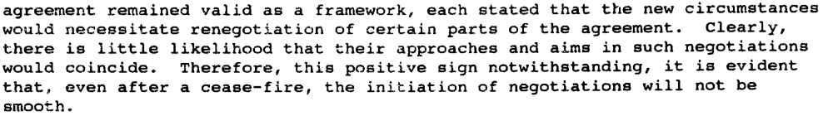
(Report of the Secretary-General on the Situation in Rwanda, UN Doc. S/1994/640 (30 May 1994), par. 29)

Assessment

Short-term compliance
No or marginal compliance (1) | Medium low compliance (2) | Medium high compliance (3) | Full or almost full compliance (4)

Considerations underlying the assessment

There was a genocide, and then the RPF took over the country, deliberately shutting the extremist elements of the former Government out of the transitional process.

Medium-term compliance

Description of the addressee(s)’ conduct

43. … They commended the Government of Rwanda for the steps it has so far taken to establish a broad-based government administration and urged the Government, towards this end, to deepen its efforts, in the spirit of the Arusha peace accord.
(Second Report of the Secretary-General on Security in the Rwandese Refugee Camps, UN Doc. S/1995/65 (25 January 1995), par. 43)

10. Government officials also emphasized that they respected, and indeed accepted the spirit of an inclusive and broad-based Government, as provided for under the Arusha peace agreement, to which their Government remained fully committed. It was pointed out that the Arusha accords were part of Rwanda’s fundamental or basic law ("loi fondamentale"). They further pointed out, however, that returning to the country was the precondition for participating in the political process. Officials also indicated that the Government had recently commenced dialogue with representatives of Rwandese refugee communities
in Burundi. They explained that dialogue with the refugee community in Zaire was not yet feasible in view of the insecurity and intimidation to which those refugees were subjected by armed elements in their midst.
(Report of the Security Council Mission to Rwanda on 12 and 13 February 1995, UN Doc. S/1995/164 (28 February 1995), par. 10)

(Report of the Secretary-General on the United Nations Assistance Mission for Rwanda, UN Doc. S/1995/457 (4 June 1995), par. 3)

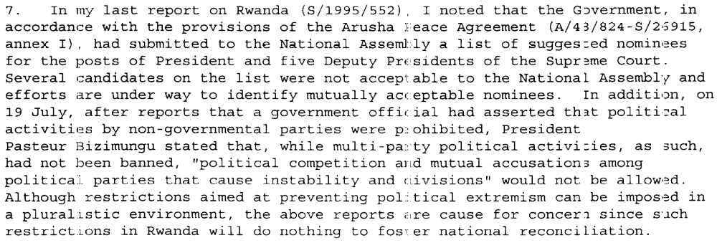(Progress Report of the Secretary-General on the United Nations Assistance Mission for Rwanda, UN Doc. S/1995/678 (8 August 1995), par. 7)

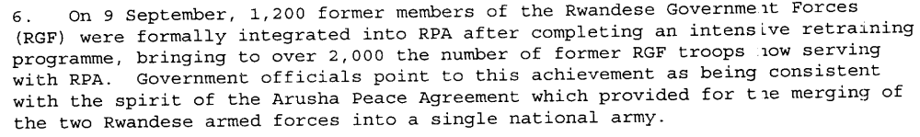
(Progress Report of the Secretary-General on the United Nations Assistance Mission for Rwanda, UN Doc. S/1995/848 (7 October 1995), par. 6, 17)

Assessment

Medium-term compliance
No or marginal compliance (1) | Medium low compliance (2) | Medium high compliance (3) | Full or almost full compliance (4)

Considerations underlying the assessment
After the genocide, the Rwandan Patriotic Front ran the Government of Rwanda, and there were very few differences between them. Certain institutions were slow to appear, but inasmuch as the relevant Rwandan political parties were engaged in the new Government of Rwanda by the victorious RPF, the former Government of Rwanda and its relevant political parties ceased to be a party to this demand.

Depth of demand

Assessment

Level of depth of demand
Low depth of demand (1) | Medium depth of demand (2) | High depth of demand (3)

Considerations underlying the assessment

Level of confidence about coding decisions

Level of confidence about coding decision
Extremely high | High | Moderate

Comments to IPI (if any)

Civil war in Rwanda

UNSC Resolution: | 912
Date of adoption: | 21 April 1994
Operative paragraph: | 5
Demand number: | 912.0511

Carla Winston

Wording of demand

Put an end to these acts of violence [attacks against UNAMIR and other United Nations
personnel leading to the deaths of and injury to several UNAMIR personnel] and respect fully international humanitarian law

List of addressees of the demand

Government of Rwanda

Short-term compliance

Description of the addressee(s)’ conduct

(Report of the Secretary-General on the Situation in Rwanda, UN Doc. S/1994/640 (30 May 1994), par. 38)

11. … Meanwhile, the situation in Rwanda has continued to deteriorate and the killing of innocent civilians has not been stopped. Furthermore, the parties have not yet come to an agreement for a cease-fire in the talks under UNAMIR auspices, nor have they respected the cease-fire to which they agreed at the recent OAU summit in Tunis.
(Letter dated 19 June 1994 from the Secretary-General addressed to the President of the Security Council, UN Doc. S/1994/728 (20 June 1994), par. 11)

Assessment

Short-term compliance
No or marginal compliance (1) | Medium low compliance (2) | Medium high compliance (3) | Full or almost full compliance (4)

Considerations underlying the assessment

There were no efforts by the Government of Rwanda to stop the genocide, and the RPF advance did not end until it was in control of the country.

Medium-term compliance

Description of the addressee(s)’ conduct

3. As members of the Security Council are aware, since the cease-fire declared on 18 July 1994, the fighting in Rwanda has all but ceased. (Progress report of the Secretary-General on the United Nations Assistance Mission for Rwanda, UN Doc. S/1994/1133 (6 October 1994), par. 3)

(Report of the Secretary-General on the United Nations Assistance Mission for Rwanda, UN Doc. S/1995/457 (4 June 1995), par. 10)

(Progress Report of the Secretary-General on the United Nations Assistance Mission for Rwanda, UN Doc. S/2996/61 (30 January 1996), par. 11)

Assessment

Medium-term compliance
No or marginal compliance (1) | Medium low compliance (2) | Medium high compliance (3) | Full or almost full compliance (4)

Considerations underlying the assessment

While certain operations of the Rwandan army were more violent than desirable, for the most part killings of civilians were avoided.

Depth of demand

Assessment

Level of depth of demand
Low depth of demand (1) | Medium depth of demand (2) | High depth of demand (3)

Considerations underlying the assessment
High depth of demand in the short term (if the Government of Rwanda had put down arms its leaders would have been captured or killed by the RPF); medium depth of demand in the medium term (violent elements remained in the refugee camps in Zaire after the genocide, which would have taken any opportunity to destabilize or re-engage the Government of Rwanda).

Level of confidence about coding decisions

Level of confidence about coding decision
Extremely high | High | Moderate

Comments to IPI (if any)

There are several drastic swings in level of compliance dependent on the before/after genocide variable, when one party to the conflict essentially became the Government of Rwanda. As the genocide was planned and in many cases carried out by the originally named Government of Rwanda, compliance is obviously low. However, the RPF-controlled, post-genocide Government of Rwanda made strong efforts to comply with UN resolutions.

Civil war in Rwanda

UNSC Resolution: | 912
Date of adoption: | 21 April 1994
Operative paragraph: | 6
Demand number: | 912.0611

Carla Winston

Wording of demand
Immediate cessation of hostilities between the forces of the Government of Rwanda and the Rwandese Patriotic Front and an end to the mindless violence and carnage which are engulfing Rwanda

List of addressees of the demand
Rwandan Patriotic Front, Government of Rwanda

Short-term compliance

Description of the addressee(s)’ conduct
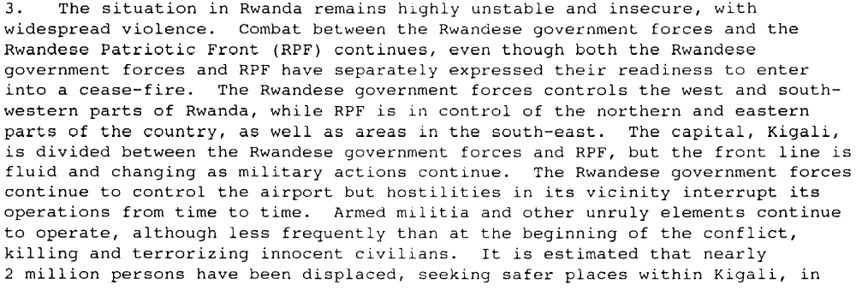
(Report of the Secretary-General on the Situation in Rwanda, UN Doc. S/1994/565 (13 May 1994), par. 3)

3. As members of the Security Council are aware, since the cease-fire declared on 18 July 1994, the fighting in Rwanda has all but ceased. (Progress report of the Secretary-General on the United Nations Assistance Mission for Rwanda, UN Doc. S/1994/1133 (6 October 1994), par. 3)

Assessment

Short-term compliance
No or marginal compliance (1) | Medium low compliance (2) | Medium high compliance (3) | Full or almost full compliance (4)

Considerations underlying the assessment

Formal hostilities did not end until the RPF’s unilateral cease-fire, after which it essentially became the leadership of the Government of Rwanda.

Medium-term compliance

Description of the addressee(s)’ conduct

(Progress Report of the Secretary-General on the United Nations Assistance Mission for Rwanda, UN Doc. S/1995/678 (8 August 1995), par. 3)

(Report of the Secretary-General on the United Nations Assistance Mission for Rwanda, UN Doc. S/1995/1002 (1 December 1995), par. 2-3, 24-25)

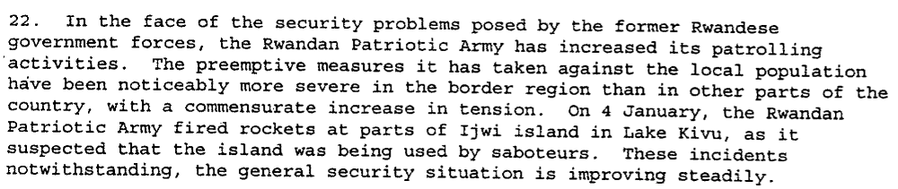(Progress Report of the Secretary-General on the United Nations Assistance Mission for Rwanda, UN Doc. S/1996/61 (30 January 1996), par. 22)

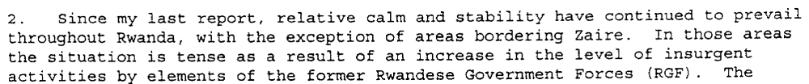 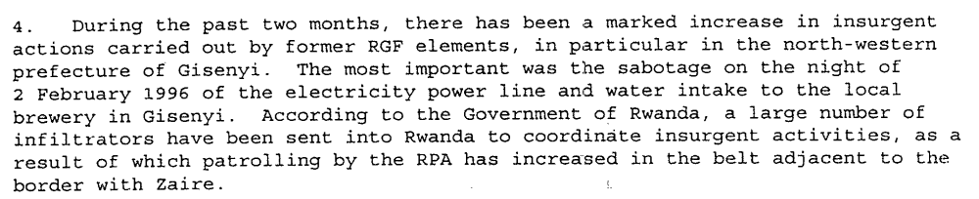(Report of the Secretary-General on the United Nations Assistance Mission for Rwanda, UN Doc. S/1996/149 (29 February 1996), par. 2,4)

Assessment

Medium-term compliance
No or marginal compliance (1) | Medium low compliance (2) | Medium high compliance (3) | Full or almost full compliance (4)

Considerations underlying the assessment

Except for some security incidents, Rwanda remained generally peacefully for the two years following this demand. The forces of the RPF were integrated into the Rwandan Patriotic Army, ending any hostilities between them.

Depth of demand

Assessment

Level of depth of demand
Low depth of demand (1) | Medium depth of demand (2) | High depth of demand (3)

Considerations underlying the assessment

High demand in the very short term, as the Government of Rwanda would have been taken over by the RPF if they stopped fighting. Medium demand in the later short and medium terms, as the RPF was already in charge of the Government and more powerful than the forces trying to topple it.

Level of confidence about coding decisions

Level of confidence about coding decision
Extremely high | High | Moderate

Comments to IPI (if any)

There are several drastic swings in level of compliance dependent on the before/after genocide variable, when one party to the conflict essentially became the Government of Rwanda. As the genocide was planned and in many cases carried out by the originally named Government of Rwanda, compliance is obviously low. However, the RPF-controlled, post-genocide Government of Rwanda made strong efforts to comply with UN resolutions.

Civil war in Rwanda

UNSC Resolution: | 912
Date of adoption: | 21 April 1994
Operative paragraph: | 12
Demand number: | 912.1211

Carla Winston

Wording of demand
Renew their commitment to this Agreement

List of addressees of the demand
Rwandan Patriotic Front, Government of Rwanda

Short-term compliance

Description of the addressee(s)’ conduct
(Report of the Secretary-General on the Situation in Rwanda, UN Doc. S/1994/640 (30 May 1994), par. 29)

Assessment

Short-term compliance
No or marginal compliance (1) | Medium low compliance (2) | Medium high compliance (3) | Full or almost full compliance (4)

Considerations underlying the assessment
Agreement reiterated for only certain parts of the Agreement, and not followed through at all, as evidenced by continuing fighting and genocide.

Medium-term compliance

Description of the addressee(s)’ conduct
43. … They commended the Government of Rwanda for the steps it has so far taken to establish a broad-based government administration and urged the Government, towards this end, to deepen its efforts, in the spirit of the Arusha peace accord.
(Second Report of the Secretary-General on Security in the Rwandese Refugee Camps, UN Doc. S/1995/65 (25 January 1995), par. 43)

10. Government officials also emphasized that they respected, and indeed accepted the spirit of an inclusive and broad-based Government, as provided for under the Arusha peace agreement, to which their Government remained fully committed. It was pointed out that the Arusha accords were part of Rwanda’s fundamental or basic law ("loi fondamentale"). They further pointed out, however, that returning to the country was the precondition for participating in the political process. Officials also indicated that the Government had recently commenced dialogue with representatives of Rwandese refugee communities
in Burundi. They explained that dialogue with the refugee community in Zaire was not yet feasible in view of the insecurity and intimidation to which those refugees were subjected by armed elements in their midst.
(Report of the Security Council Mission to Rwanda on 12 and 13 February 1995, UN Doc. S/1995/164 (28 February 1995), par. 10)

(Progress Report of the Secretary-General on the United Nations Assistance Mission for Rwanda, UN Doc. S/1995/848 (7 October 1995), par. 6)

Assessment

Medium-term compliance
No or marginal compliance (1) | Medium low compliance (2) | Medium high compliance (3) | Full or almost full compliance (4)

Considerations underlying the assessment
Commitment to as much of the spirit of the Arusha Accord as could be feasibly undertaken considering changed circumstances, with the exception of certain political considerations on the part of the RPF/Government of Rwanda

Depth of demand

Assessment

Level of depth of demand
Low depth of demand (1) | Medium depth of demand (2) | High depth of demand (3)

Considerations underlying the assessment

Level of confidence about coding decisions

Level of confidence about coding decision
Extremely high | High | Moderate

Comments to IPI (if any)

There are several drastic swings in level of compliance dependent on the before/after genocide variable, when one party to the conflict essentially became the Government of Rwanda. As the genocide was planned and in many cases carried out by the originally named Government of Rwanda, compliance is obviously low. However, the RPF-controlled, post-genocide Government of Rwanda made strong efforts to comply with UN resolutions.

Civil war in Rwanda

UNSC Resolution: | 912
Date of adoption: | 21 April 1994
Operative paragraph: | 13
Demand number: | 912.1311

Carla Winston

Wording of demand
Cooperate fully in ensuring the unimpeded delivery of humanitarian assistance to all in need throughout Rwanda

List of addressees of the demand
Rwandan Patriotic Front, Government of Rwanda

Short-term compliance

Description of the addressee(s)’ conduct
(Report of the Secretary-General on the Situation in Rwanda, UN Doc. S/1994/565 (13 May 1994), par. 8-9)

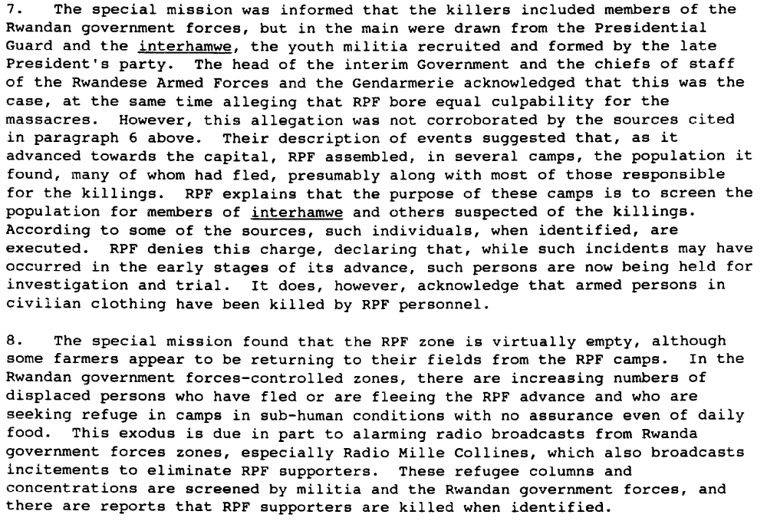
40.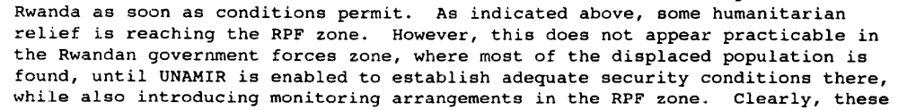
(Report of the Secretary-General on the Situation in Rwanda, UN Doc. S/1994/640 (30 May 1994), par. 7-8, 40)

Assessment

Short-term compliance
No or marginal compliance (1) | Medium low compliance (2) | Medium high compliance (3) | Full or almost full compliance (4)

Considerations underlying the assessment
Genocide, crimes against humanity and selected war crimes occurred during the 3 months immediately after the demand.

Medium-term compliance

Description of the addressee(s)’ conduct

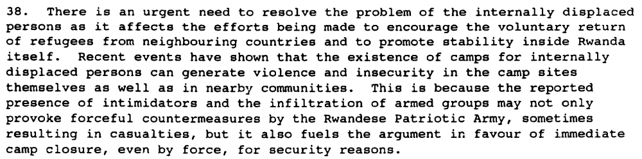
(Progress Report of the Secretary-General on the United Nations Assistance Mission for Rwanda, UN Doc. S/1995/107 (6 February 1995), par. 38)

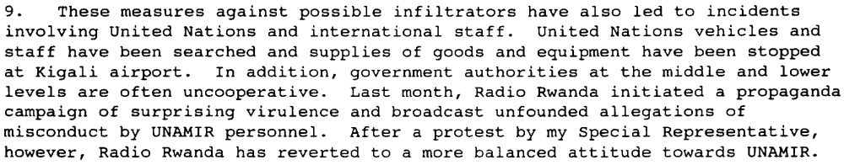
(Progress Report of the Secretary-General on the United Nations Assistance Mission for Rwanda, UN Doc. S/1995/297 (9 April 1995), par. 9)

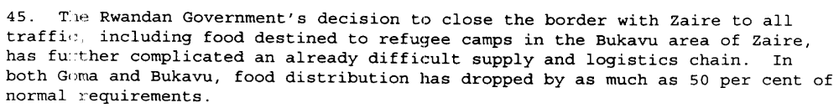 (Report of the Secretary-General on the United Nations Assistance Mission for Rwanda, UN Doc. S/1995/457 (4 June 1995), par. 10, 45)

Assessment

Medium-term compliance
No or marginal compliance (1) | Medium low compliance (2) | Medium high compliance (3) | Full or almost full compliance (4)

Considerations underlying the assessment
Security fears on the part of the Rwandan government often interfered with the delivery and maintenance of humanitarian aid and services.

Depth of demand

Assessment

Level of depth of demand
Low depth of demand (1) | Medium depth of demand (2) | High depth of demand (3)

Considerations underlying the assessment
International humanitarian relief agencies were unable to prevent the anti-government opposition from using concentrations of displaced persons to plan and launch attacks on the government.

Level of confidence about coding decisions

Level of confidence about coding decision
Extremely high | High | Moderate

Comments to IPI (if any)

Civil war in Rwanda

UNSC Resolution: | 918
Date of adoption: | 17 May 1994
Operative paragraph: | 1
Demand number: | 918.0111

Carla Winston

Wording of demand
Immediately cease hostilities, agree to a cease-fire, and bring an end to the mindless violence and carnage engulfing Rwanda

List of addressees of the demand
Rwandan Patriotic Front, Government of Rwanda

Short-term compliance

Description of the addressee(s)’ conduct
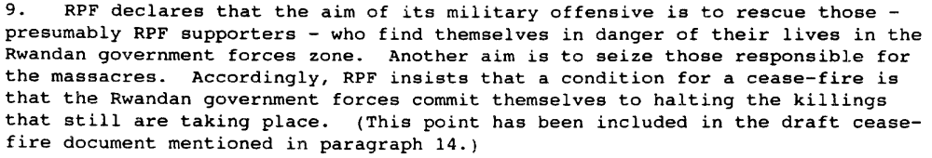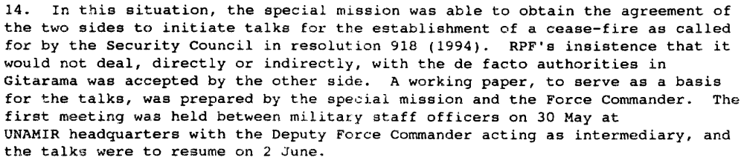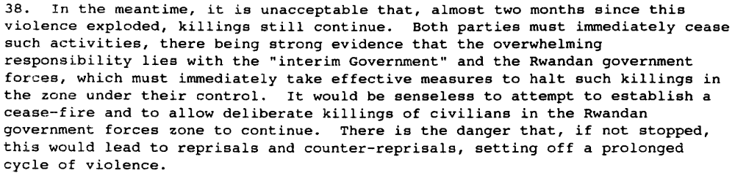
(Report of the Secretary-General on the Situation in Rwanda, UN Doc. S/1994/640 (30 May 1994), par. 6,9,14,38)

3. As members of the Security Council are aware, since the cease-fire declared on 18 July 1994, the fighting in Rwanda has all but ceased. (Progress report of the Secretary-General on the United Nations Assistance Mission for Rwanda, UN Doc. S/1994/1133 (6 October 1994), par. 3)

Assessment

Short-term compliance
No or marginal compliance (1) | Medium low compliance (2) | Medium high compliance (3) | Full or almost full compliance (4)

Considerations underlying the assessment

The Government of Rwanda and its associated forces continued to carry out the genocide until they were forced out of the country by the advancing RPF; the RPF declared a unilateral cease-fire 2 months after the demand.

Medium-term compliance

Description of the addressee(s)’ conduct
(Progress Report of the Secretary-General on the United Nations Assistance Mission for Rwanda, UN Doc. S/1995/678 (8 August 1995), par. 3)

Assessment

Medium-term compliance
No or marginal compliance (1) | Medium low compliance (2) | Medium high compliance (3) | Full or almost full compliance (4)

Considerations underlying the assessment
Except for some security incidents, Rwanda remained generally peacefully for the two years following this demand. It did not clear out the Zairian refugee camps by force until after the two-year period had elapsed.

Depth of demand

Assessment

Level of depth of demand
Low depth of demand (1) | Medium depth of demand (2) | High depth of demand (3)

Considerations underlying the assessment

High demand in the very short term, as the Government of Rwanda would have been taken over by the RPF if they stopped fighting. Medium demand in the later short and medium terms, as the RPF was already in charge of the Government and more powerful than the forces trying to topple it.

Level of confidence about coding decisions

Level of confidence about coding decision
Extremely high | High | Moderate

Comments to IPI (if any)

There are several drastic swings in level of compliance dependent on the before/after genocide variable, when one party to the conflict essentially became the Government of Rwanda. As the genocide was planned and in many cases carried out by the originally named Government of Rwanda, compliance is obviously low. However, the RPF-controlled, post-genocide Government of Rwanda made strong efforts to comply with UN resolutions.

Civil war in Rwanda

UNSC Resolution: | 918
Date of adoption: | 17 May 1994
Operative paragraph: | 10
Demand number: | 918.1011

Carla Winston

Wording of demand
Cooperate fully with UNAMIR in the implementation of its mandate and in particular in ensuring its freedom of movement and the unimpeded delivery of humanitarian assistance, and treat Kigali airport as a neutral zone under the control of UNAMIR.

List of addressees of the demand
Interahamwe, Government of Rwanda, Rwandan Patriotic Front

Short-term compliance

Description of the addressee(s)’ conduct
(Report of the Secretary-General on the Situation in Rwanda, UN Doc. S/1994/640 (30 May 1994), par. 19,20)

3. … While over two million Rwandese refugees remain in the neighbouring countries, the Government has undertaken efforts, in coordination with my Special Representative and other United Nations officials on the ground, to encourage their safe and voluntary return to Rwanda.
(Progress report of the Secretary-General on the United Nations Assistance Mission for Rwanda, UN Doc. S/1994/1133 (6 October 1994), par. 3)

29. Relations between UNAMIR and the RPA have been cordial and cooperative. However, movement restrictions have sometimes been imposed on UNAMIR troops. The formal understanding between UNAMIR and the BBGNU, particularly with reference to the United Nations Status-of-Forces Agreement with Rwanda, is that there should be no restrictions on the movement or deployment of UNAMIR personnel and vehicles throughout Rwanda. However, as illustrated by the three-week delay in providing clearance to occupy accommodation and concurrently deploy troops in the north-east and south-east (sectors 1 and 2), as well as periodic, local limitations placed on movements of UNAMIR troops in the south and north-west (sectors 3 and 5), the reality on the ground is sometimes different. In addition, some local RPA commanders have sometimes indicated that they are under instructions to deny UNAMIR access to areas where RPA troops are deployed. When such incidents are brought to the attention of senior government officials, they are usually quickly resolved.
(Progress Report of the Secretary-General on the United Nations Assistance Mission for Rwanda, UN Doc. S/1994/1133 (6 October 1994), par. 29)

37. … there is increasing tension between the Rwandese military and UNAMIR and incidents obstructing UNAMIR’s ability to carry out its mandate are becoming more frequent.
(Report of the Secretary-General on Security in the Rwandese Refugee Camps, UN Doc. S/1994/1308 (18 November 1994), par. 37)

7. The former Rwandese political leaders, Rwandese government forces soldiers and militia control the camps, though the degree of control varies from area to area. They are determined to ensure by force, if necessary, that the refugees do not repatriate to Rwanda. They also make it difficult for relief agencies to carry out their work in safety, because they attempt to control the agencies’ activities in the camps and prevent relief supplies from reaching those in need. It is believed that these elements may be preparing for an armed invasion of Rwanda and that they may be stockpiling and selling food distributed by relief agencies in preparation for such an invasion. There have already been some cross border incursions. Security is further undermined by general lawlessness, extortion, banditry and gang warfare between groups fighting for control of the camps. As a result of these threats to security, non-governmental organizations responsible for the distribution of relief supplies in the camps have begun to withdraw.
…
9. Estimates of the number of former Rwandese government forces personnel in Zaire differ but they probably amount to about 50,000 persons, including dependants. In south Kivu, they are located in two separate military camps. In north Kivu, on the other hand, they are living among the refugees and are often indistinguishable from them, since many no longer wear uniform. It seems to be their intention to regain power in Rwanda and there are reports of continuing military activity by them along the Zairian/Rwandese border in Kanganiro and Kamanyola. However, they have not so far been as significant a factor for insecurity in the camps as have the militia.
(Report of the Secretary-General on Security in the Rwandese Refugee Camps, UN Doc. S/1994/1308 (18 November 1994), par. 7,9)

Assessment

Short-term compliance
No or marginal compliance (1) | Medium low compliance (2) | Medium high compliance (3) | Full or almost full compliance (4)

Considerations underlying the assessment
No or marginal compliance by the Interahamwe, no compliance in the very short term by the government of Rwanda, but medium high compliance by the RPF and the RPF-controlled post-genocide Government of Rwanda.

Medium-term compliance

Description of the addressee(s)’ conduct
(Progress Report of the Secretary-General on the United Nations Assistance Mission for Rwanda, UN Doc. S/1995/107 (6 February 1995), par. 11)

(Progress Report of the Secretary-General on the United Nations Assistance Mission for Rwanda, UN Doc. S/1995/297 (9 April 1995), par. 9)
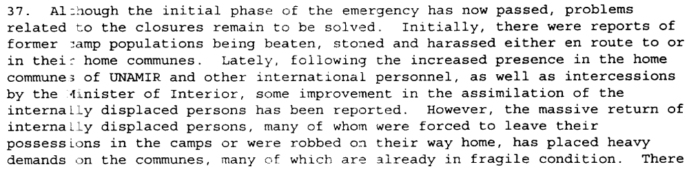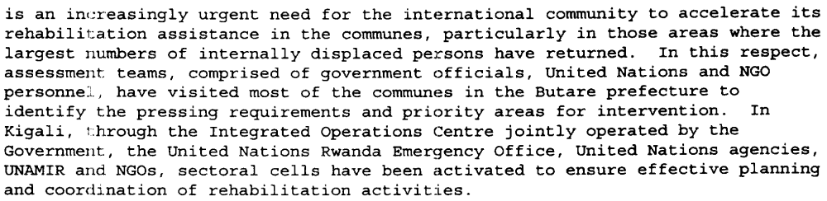
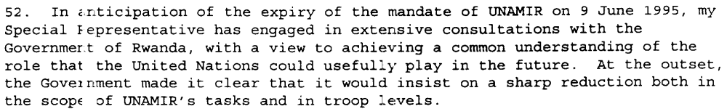 (Report of the Secretary-General on the United Nations Assistance Mission for Rwanda, UN Doc. S/1995/457 (4 June 1995), par. 37, 45, 52)

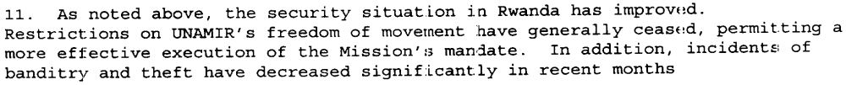
(Progress Report of the Secretary-General on the United Nations Assistance Mission for Rwanda, UN Doc. S/1995/678 (8 August 1995), par. 3, 11)

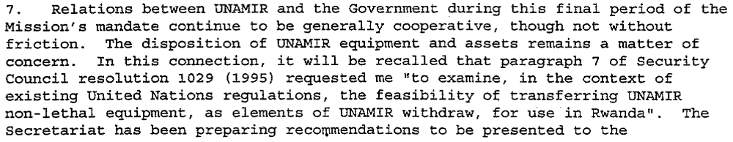
Progress Report of the Secretary-General on the United Nations Assistance Mission for Rwanda, UN Doc. S/2996/61 (30 January 1996), par. 7-8)

Assessment

Medium-term compliance
No or marginal compliance (1) | Medium low compliance (2) | Medium high compliance (3) | Full or almost full compliance (4)

Considerations underlying the assessment
Decreasing compliance over time by the Government of Rwanda in the first year after demand, then increased compliance based on changed mission rules of UNAMIR. Continued lack of compliance by the Interahamwe.

Depth of demand

Assessment

Level of depth of demand
Low depth of demand (1) | Medium depth of demand (2) | High depth of demand (3)

Considerations underlying the assessment
Kigali airport was seen by both the RPF and the Government of Rwanda as a key strategic asset, and leaving it to UNAMIR would have weakened their positions in the conflict.

Level of confidence about coding decisions

Level of confidence about coding decision
Extremely high | High | Moderate

Comments to IPI (if any)

Civil war in Rwanda

UNSC Resolution: | 918
Date of adoption: | 17 May 1994
Operative paragraph: | 11
Demand number: | 918.1111

Carla Winston

Wording of demand

Strictly respect the persons and premises of the United Nations and other organizations serving in Rwanda, and refrain from any acts of intimidation or violence against personnel engaged in humanitarian and peace-keeping work

List of addressees of the demand

Interahamwe, Government of Rwanda, Rwandan Patriotic Front

Short-term compliance

Description of the addressee(s)’ conduct
(Report of the Secretary-General on the Situation in Rwanda, UN Doc. S/1994/640 (30 May 1994), par. 4)

4. I must again reiterate my admiration for the dedication and courage of all UNAMIR personnel, despite serious casualties. (Letter dated 19 June 1994 from the Secretary-General addressed to the President of the Security Council, UN Doc. S/1994/728 (20 June 1994), par. 4)

Assessment

Short-term compliance
No or marginal compliance (1) | Medium low compliance (2) | Medium high compliance (3) | Full or almost full compliance (4)

Considerations underlying the assessment
There was no further killing of peacekeepers or humanitarian aid workers, but there were serious security risks created by the ongoing hostilities.

Medium-term compliance

Description of the addressee(s)’ conduct

16. The threat to the safety of international relief workers is also significant. There are now 45 non-governmental organizations (NGOs) and about 1,600 international relief workers in the Goma area alone. A large number of local Zairian and Rwandese relief personnel also work in the camps. The security threat to these relief workers includes harassment, especially on their way to and from the camps when they are frequently stopped, in some cases at gunpoint, and asked to pay tolls or are threatened for other reasons. There is also a significant risk that relief workers can be caught up in civil disturbances or incidents between refugees themselves. Some relief workers have been threatened by refugees who for some reason wrongly perceive them to be opposed to their interests.
17. Initially, the leaders in the camps were called upon to facilitate the delivery of relief assistance. Unfortunately, they misused this responsibility by using the delivery of assistance to persuade refugees to behave according to their interests and by hoarding and/or selling such assistance rather than distributing it. As a result, the incidence of malnutrition, especially in the most vulnerable groups, including women, children and the elderly, was initially much higher than it should have been given the level of assistance provided. Recently, it has however been possible to provide assistance more directly to the beneficiaries and, as a result, both the negative influence of the camp leaders and levels of malnutrition have been reduced. In addition, UNHCR is about to proceed with the registration of refugees in the camps, which will also help to ensure more effective delivery of relief assistance.
(Second Report of the Secretary-General on Security in the Rwandese Refugee Camps, UN Doc. S/1995/65 (25 January 1995), par. 16-17)

(Progress Report of the Secretary-General on the United Nations Assistance Mission for Rwanda, UN Doc. S/1995/297 (9 April 1995), par. 9)

7. The former Rwandese political leaders, Rwandese government forces soldiers and militia control the camps, though the degree of control varies from area to area. They are determined to ensure by force, if necessary, that the refugees do not repatriate to Rwanda. They also make it difficult for relief agencies to carry out their work in safety, because they attempt to control the agencies’ activities in the camps and prevent relief supplies from reaching those in need. It is believed that these elements may be preparing for an armed invasion of Rwanda and that they may be stockpiling and selling food distributed by relief agencies in preparation for such an invasion. There have already been some cross border incursions. Security is further undermined by general lawlessness, extortion, banditry and gang warfare between groups fighting for control of the camps. As a result of these threats to security, non-governmental organizations responsible for the distribution of relief supplies in the camps have begun to withdraw.
(Report of the Secretary-General on Security in the Rwandese Refugee Camps, UN Doc. S/1994/1308 (18 November 1994), par. 7)

Assessment

Medium-term compliance
No or marginal compliance (1) | Medium low compliance (2) | Medium high compliance (3) | Full or almost full compliance (4)

Considerations underlying the assessment
Although the Interahamwe did not comply at all with this demand, placing other United Nations and international personnel were at significant personal risk in the Goma refugee camps, they were at the time located principally outside Rwanda, and out of the zone of operations of UNAMIR. The RPF-controlled Government of Rwanda did rather better at compliance, despite isolated incidents.

Depth of demand

Assessment

Level of depth of demand
Low depth of demand (1) | Medium depth of demand (2) | High depth of demand (3)

Considerations underlying the assessment
As UNAMIR’s mandate did not allow it to engage in hostilities, and humanitarian relief organizations pose no overt threat to any warring party, there should have been no reason to threaten their safety.

Level of confidence about coding decisions

Level of confidence about coding decision
Extremely high | High | Moderate

Comments to IPI (if any)

Civil war in Rwanda

UNSC Resolution: | 925
Date of adoption: | 8 June 1994
Operative paragraph: | 6
Demand number: | 925.0611

Carla Winston

Wording of demand

Cease hostilities, agree to a cease-fire and immediately take steps to bring an end to systematic killings in areas under their control

List of addressees of the demand

Interahamwe, Government of Rwanda, Rwandan Patriotic Front

Short-term compliance

Description of the addressee(s)’ conduct

11. … Meanwhile, the situation in Rwanda has continued to deteriorate and the killing of innocent civilians has not been stopped. Furthermore, the parties have not yet come to an agreement for a cease-fire in the talks under UNAMIR auspices, nor have they respected the cease-fire to which they agreed at the recent OAU summit in Tunis. (Letter dated 19 June 1994 from the Secretary-General addressed to the President of the Security Council, UN Doc. S/1994/728 (20 June 1994), par. 11)

3. As members of the Security Council are aware, since the cease-fire declared on 18 July 1994, the fighting in Rwanda has all but ceased. The Broad-based Government of National Unity (BBGNU), installed at Kigali on 19 July, has established control over the whole of the national territory.
(Progress report of the Secretary-General on the United Nations Assistance Mission for Rwanda, UN Doc. S/1994/1133 (6 October 1994), par. 3)

23. Since the 18 July 1994 cease-fire and the formation of the BBGNU a day later, the military situation in Rwanda has been relatively calm.
(Progress Report of the Secretary-General on the United Nations Assistance Mission for Rwanda, UN Doc. S/1994/1133 (6 October 1994), par. 23)

7. The former Rwandese political leaders, Rwandese government forces soldiers and militia control the camps, though the degree of control varies from area to area. They are determined to ensure by force, if necessary, that the refugees do not repatriate to Rwanda. They also make it difficult for relief agencies to carry out their work in safety, because they attempt to control the agencies’ activities in the camps and prevent relief supplies from reaching those in need. It is believed that these elements may be preparing for an armed invasion of Rwanda and that they may be stockpiling and selling food distributed by relief agencies in preparation for such an invasion. There have already been some cross border incursions. Security is further undermined by general lawlessness, extortion, banditry and gang warfare between groups fighting for control of the camps. As a result of these threats to security, non-governmental organizations responsible for the distribution of relief supplies in the camps have begun to withdraw.
…
9. Estimates of the number of former Rwandese government forces personnel in Zaire differ but they probably amount to about 50,000 persons, including dependants. In south Kivu, they are located in two separate military camps. In north Kivu, on the other hand, they are living among the refugees and are often indistinguishable from them, since many no longer wear uniform. It seems to be their intention to regain power in Rwanda and there are reports of continuing military activity by them along the Zairian/Rwandese border in Kanganiro and Kamanyola. However, they have not so far been as significant a factor for insecurity in the camps as have the militia.
(Report of the Secretary-General on Security in the Rwandese Refugee Camps, UN Doc. S/1994/1308 (18 November 1994), par. 7,9)

Assessment

Short-term compliance
No or marginal compliance (1) | Medium low compliance (2) | Medium high compliance (3) | Full or almost full compliance (4)

Considerations underlying the assessment

Killings continued well into July, and only one party (the victorious one, the RPF) declared a cease-fire. It took six weeks from the date of the demand, however, and must therefore be discounted for slow action.

Medium-term compliance

Description of the addressee(s)’ conduct

(Progress Report of the Secretary-General on the United Nations Assistance Mission for Rwanda, UN Doc. S/1995/297 (9 April 1995), par. 9)

19. Both the Government of Rwanda and the international community are seriously concerned by persistent reports about arms shipments into Goma airport, allegedly for arming the former Rwandese government forces, as well as about the training of these forces on Zairian territory.
(Third Report of the Secretary-General on Security in the Rwandese Refugee Camps, UN Doc. S/1995/304 (14 April 1995), par. 19)

(Report of the Secretary-General on the United Nations Assistance Mission for Rwanda, UN Doc. S/1995/457 (4 June 1995), par. 3)

(Progress Report of the Secretary-General on the United Nations Assistance Mission for Rwanda, UN Doc. S/1995/678 (8 August 1995), par. 11, 41)

(Progress Report of the Secretary-General on the United Nations Assistance Mission for Rwanda, UN Doc. S/2996/61 (30 January 1996), par. 11)

Assessment

Medium-term compliance
No or marginal compliance (1) | Medium low compliance (2) | Medium high compliance (3) | Full or almost full compliance (4)

Considerations underlying the assessment
The RPF-controlled Government of Rwanda was mostly compliant, while the former Government-Interahamwe were no longer engaged in systematic killings in areas under their control, but did not cease hostilities.

Depth of demand

Assessment

Level of depth of demand
Low depth of demand (1) | Medium depth of demand (2) | High depth of demand (3)

Considerations underlying the assessment
Ceasing hostilities in the short term would have been disastrous for the future survival of either the RPF or the Interahamwe.

Level of confidence about coding decisions

Level of confidence about coding decision
Extremely high | High | Moderate

Comments to IPI (if any)

Civil war in Rwanda

UNSC Resolution: | 925
Date of adoption: | 8 June 1994
Operative paragraph: | 7
Demand number: | 925.0711

Carla Winston

Wording of demand
Adhere to those assurances

List of addressees of the demand
Rwandan Patriotic Front, Government of Rwanda

Short-term compliance

Description of the addressee(s)’ conduct
11. … Meanwhile, the situation in Rwanda has continued to deteriorate and the killing of innocent civilians has not been stopped. Furthermore, the parties have not yet come to an agreement for a cease-fire in the talks under UNAMIR auspices, nor have they respected the cease-fire to which they agreed at the recent OAU summit in Tunis.
(Letter dated 19 June 1994 from the Secretary-General addressed to the President of the Security Council, UN Doc. S/1994/728 (20 June 1994), par. 11)

29. Relations between UNAMIR and the RPA have been cordial and cooperative. However, movement restrictions have sometimes been imposed on UNAMIR troops. The formal understanding between UNAMIR and the BBGNU, particularly with reference to the United Nations Status-of-Forces Agreement with Rwanda, is that there should be no restrictions on the movement or deployment of UNAMIR personnel and vehicles throughout Rwanda. However, as illustrated by the three-week delay in providing clearance to occupy accommodation and concurrently deploy troops in the north-east and south-east (sectors 1 and 2), as well as periodic, local limitations placed on movements of UNAMIR troops in the south and north-west (sectors 3 and 5), the reality on the ground is sometimes different. In addition, some local RPA commanders have sometimes indicated that they are under instructions to deny UNAMIR access to areas where RPA troops are deployed. When such incidents are brought to the attention of senior government officials, they are usually quickly resolved.
(Progress Report of the Secretary-General on the United Nations Assistance Mission for Rwanda, UN Doc. S/1994/1133 (6 October 1994), par. 29)

37. … there is increasing tension between the Rwandese military and UNAMIR and incidents obstructing UNAMIR’s ability to carry out its mandate are becoming more frequent.
(Report of the Secretary-General on Security in the Rwandese Refugee Camps, UN Doc. S/1994/1308 (18 November 1994), par. 37)

Assessment

Short-term compliance
No or marginal compliance (1) | Medium low compliance (2) | Medium high compliance (3) | Full or almost full compliance (4)

Considerations underlying the assessment
Very little compliance by the Government of Rwanda or the Rwandan Patriotic Front until the unilateral cease-fire of July 18, 1994, and then increased compliance, with some tension between the Rwandese military and UNAMIR leading to partially obstructed work, in the post-genocide period.

Medium-term compliance

Description of the addressee(s)’ conduct

Progress Report of the Secretary-General on the United Nations Assistance Mission for Rwanda, UN Doc. S/1995/107 (6 February 1995), par. 13)

(Progress Report of the Secretary-General on the United Nations Assistance Mission for Rwanda, UN Doc. S/1995/297 (9 April 1995), par. 10, 20-24, 48)

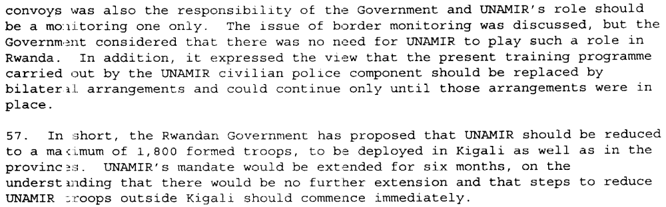
(Report of the Secretary-General on the United Nations Assistance Mission for Rwanda, UN Doc. S/1995/457 (4 June 1995), par. 52, 56, 57)

Report of the Secretary-General on the United Nations Assistance Mission for Rwanda, UN Doc. S/1995/678 (8 August 1995), par. 3, 11)

Progress Report of the Secretary-General on the United Nations Assistance Mission for Rwanda, UN Doc. S/2996/61 (30 January 1996), par. 7-8)

Assessment

Medium-term compliance
No or marginal compliance (1) | Medium low compliance (2) | Medium high compliance (3) | Full or almost full compliance (4)

Considerations underlying the assessment
Decreasing compliance over time by the Government of Rwanda in the first year after demand, then increased compliance based on changed mission rules of UNAMIR. Generally, the Government of Rwanda has adhered to assurances that it will allow UNAMIR to do its work, but there were several incidents in which UNAMIR staff or operations were harassed or temporarily impeded from operating. After a re-negotiation of UNAMIR’s role in Rwanda, compliance increased.

Depth of demand

Assessment

Level of depth of demand
Low depth of demand (1) | Medium depth of demand (2) | High depth of demand (3)

Considerations underlying the assessment
UNAMIR’s operations posed very little security or political risk to the Government of Rwanda; its earlier frustrations were at UNAMIR’s lack of speed or efficiency, and the Government was able to re-negotiate the terms of UNAMIR’s operations to something more to its liking, which posed even less of a threat than previously.

Level of confidence about coding decisions

Level of confidence about coding decision
Extremely high | High | Moderate

Comments to IPI (if any)

Civil war in Rwanda

UNSC Resolution: | 925
Date of adoption: | 8 June 1994
Operative paragraph: | 8
Demand number: | 925.0811

Carla Winston

Wording of demand
Cease forthwith any incitement, especially through the mass media, to violence or ethnic hatred

List of addressees of the demand
Interahamwe, Government of Rwanda, Rwandan Patriotic Front

Short-term compliance

Description of the addressee(s)’ conduct
8. During the month of August, members of the Government made several visits to refugee camps in Zaire in an attempt to encourage the refugees to return voluntarily to their places of origin. Those efforts have caused some increase in the numbers of returning refugees. Some 360,000 refugees have returned to Rwanda spontaneously since the cease-fire on 18 July. The Government has expressed its concern about the presence in the camps of elements who continue to incite people to flee from Rwanda and to threaten those in the camps from returning to their homes and farms in Rwanda. In September, reports and preliminary investigations pointed to the possibility that refugees returning to Rwanda might have been subjected to reprisals by government troops; further investigations are in progress (paras. 14 and 15 below).
9. The misinformation propagated during and after the hostilities is considered to have been a major factor in inciting the massacres and subsequent exodus of refugees into neighbouring countries. Information remains an important element in creating both stability in the country and a climate conducive to the safe and voluntary return of refugees and displaced persons. Rwanda has no newspapers or television, and radio is the only medium of information. UNAMIR, in association with concerned United Nations agencies, is therefore developing a broadcasting capability in order to provide the Rwandese people with factual information on the situation in their country, to assist in explaining UNAMIR’s mandate and to disseminate information on humanitarian programmes. UNAMIR is currently installing at Kigali an FM broadcasting capability with a 20-kilometre range. Additional equipment, which would enable UNAMIR broadcasts to cover the whole country, is being procured and the necessary specialists recruited. UNAMIR has also asked the Rwandese authorities for formal authorization to begin broadcasting and for a frequency allocation. I hope the Government will respond positively to those requests in the near future.
(Progress Report of the Secretary-General on the United Nations Assistance Mission for Rwanda, UN Doc. S/1994/1133 (6 October 1994), par. 8-9)

15. More specifically, the refugees are intimidated from publicly expressing their desire to return to Rwanda. The lives of such people, as well as the lives of politically moderate refugees or those who may have intermarried or are suspected of being infiltrators are seriously threatened and some of them are known to have been killed. There is also a significant threat of civil disturbances in the camps. This threat is especially acute when refugees congregate together, for example, when relief supplies are distributed. In addition, as in any area containing a large number of people living in highly dense and impoverished conditions, common crime is prevalent in the camps.
(Second Report of the Secretary-General on Security in the Rwandese Refugee Camps, UN Doc. S/1995/65 (25 January 1995), par. 15)

Assessment

Short-term compliance
No or marginal compliance (1) | Medium low compliance (2) | Medium high compliance (3) | Full or almost full compliance (4)

Considerations underlying the assessment
Principal addressees are the Interahamwe.

Medium-term compliance

Description of the addressee(s)’ conduct
(Progress Report of the Secretary-General on the United Nations Assistance Mission for Rwanda, UN Doc. S/1995/297 (9 April 1995), par. 9)

11. Further contributing to that decline was the reduction of rations in the camps, necessitated by overall shortages of relevant food items in the region, although it was perceived by the refugees as a deliberate measure to force their repatriation. On 31 March, the food situation in the Goma camps was described by the World Food Programme (WFP) as critical. Surveys indicated that malnutrition in these camps was increasing. Acute food shortages continue, but positive changes are expected by UNHCR in the coming weeks following a regional meeting on logistics in Nairobi. The militia of the former Rwandese Government are exploiting the food shortage to incite the refugee population and reinforce their campaign against repatriation.
(Third Report of the Secretary-General on Security in the Rwandese Refugee Camps, UN Doc. S/1995/304 (14 April 1995), par. 11)

Assessment

Medium-term compliance
No or marginal compliance (1) | Medium low compliance (2) | Medium high compliance (3) | Full or almost full compliance (4)

Considerations underlying the assessment
Although the principal addressee remains the Interahamwe, the Government of Rwanda bears increased responsibility given its control over the airwaves in its territory. It is more compliant than the Interahamwe, and its incitement is not ethnically motivated.

Depth of demand

Assessment

Level of depth of demand
Low depth of demand (1) | Medium depth of demand (2) | High depth of demand (3)

Considerations underlying the assessment

Level of confidence about coding decisions

Level of confidence about coding decision
Extremely high | High | Moderate

Comments to IPI (if any)

Civil war in Rwanda

UNSC Resolution: | 925
Date of adoption: | 8 June 1994
Operative paragraph: | 11
Demand number: | 925.1111

Carla Winston

Wording of demand
Strictly respect the persons and premises of the United Nations and other organizations serving in Rwanda, and refrain from any acts of intimidation or violence against personnel engaged in humanitarian and peace-keeping work

List of addressees of the demand
Interahamwe, Government of Rwanda, Rwandan Patriotic Front

Short-term compliance

Description of the addressee(s)’ conduct

(Report of the Secretary-General on the Situation in Rwanda, UN Doc. S/1994/640 (30 May 1994), par. 4)

4. I must again reiterate my admiration for the dedication and courage of all UNAMIR personnel, despite serious casualties.
(Letter dated 19 June 1994 from the Secretary-General addressed to the President of the Security Council, UN Doc. S/1994/728 (20 June 1994), par. 4)

Assessment

Short-term compliance
No or marginal compliance (1) | Medium low compliance (2) | Medium high compliance (3) | Full or almost full compliance (4)

Considerations underlying the assessment
- There was no further killing of peacekeepers or humanitarian aid workers, but there were serious security risks created by the ongoing hostilities.

Medium-term compliance

Description of the addressee(s)’ conduct

2. While there have been some positive developments since my report of
18 November 1994 (S/1994/1308) in respect of the creation of conditions
conducive to repatriation, the continuing presence of nearly 2 million Rwandese refugees in Burundi, the United Republic of Tanzania and Zaire is a matter of serious concern. The general security situation in the camps remains dangerous for both refugees and relief workers. The situation is also potentially destabilizing for the host countries and for the subregion as a whole. The only effective solution to this problem remains the safe and voluntary repatriation of the refugees. Accordingly, and taking into account the improving situation within Rwanda, the Office of the United Nations High Commissioner for Refugees (UNHCR) reiterated, in December 1994, that it would assist, wherever possible, the voluntary return of those refugees who wished to go back to Rwanda.
16. The threat to the safety of international relief workers is also significant. There are now 45 non-governmental organizations (NGOs) and about 1,600 international relief workers in the Goma area alone. A large number of local Zairian and Rwandese relief personnel also work in the camps. The security threat to these relief workers includes harassment, especially on their way to and from the camps when they are frequently stopped, in some cases at gunpoint, and asked to pay tolls or are threatened for other reasons. There is also a significant risk that relief workers can be caught up in civil disturbances or incidents between refugees themselves. Some relief workers have been threatened by refugees who for some reason wrongly perceive them to be opposed to their interests.
17. Initially, the leaders in the camps were called upon to facilitate the delivery of relief assistance. Unfortunately, they misused this responsibility by using the delivery of assistance to persuade refugees to behave according to their interests and by hoarding and/or selling such assistance rather than distributing it. As a result, the incidence of malnutrition, especially in the most vulnerable groups, including women, children and the elderly, was initially much higher than it should have been given the level of assistance provided. Recently, it has however been possible to provide assistance more directly to the beneficiaries and, as a result, both the negative influence of the camp leaders and levels of malnutrition have been reduced. In addition, UNHCR is about to proceed with the registration of refugees in the camps, which will also help to ensure more effective delivery of relief assistance.
(Second Report of the Secretary-General on Security in the Rwandese Refugee Camps, UN Doc. S/1995/65 (25 January 1995), par. 2, 16-17)

(Progress Report of the Secretary-General on the United Nations Assistance Mission for Rwanda, UN Doc. S/1995/297 (9 April 1995), par. 20-22)

Assessment

Medium-term compliance
No or marginal compliance (1) | Medium low compliance (2) | Medium high compliance (3) | Full or almost full compliance (4)

Considerations underlying the assessment

Although the Interahamwe did not comply at all with this demand, they were at the time located principally outside Rwanda and out of the zone of operations of UNAMIR. The RPF-controlled Government of Rwanda did rather better at compliance, despite isolated incidents.

Depth of demand

Assessment

Level of depth of demand
Low depth of demand (1) | Medium depth of demand (2) | High depth of demand (3)

Considerations underlying the assessment
As UNAMIR’s mandate did not allow it to engage in hostilities, and humanitarian relief organizations pose no overt threat to any warring party, there should have been no reason to threaten their safety.

Level of confidence about coding decisions

Level of confidence about coding decision
Extremely high | High | Moderate

Comments to IPI (if any)

Civil war in Rwanda

UNSC Resolution: | 925
Date of adoption: | 8 June 1994
Operative paragraph: | 16
Demand number: | 925.1611

Carla Winston

Wording of demand

Undertake serious efforts to bring about political reconciliation

List of addressees of the demand

Interahamwe, Government of Rwanda, Rwandan Patriotic Front

Short-term compliance

Description of the addressee(s)’ conduct

5. In order to create stability and lasting peace in Rwanda, the Government seems to recognize the need to include all its citizenry, regardless of ethnicity, within its administrative and security structures. The President of Rwanda has assured my Special Representative that efforts are continuing to make the Government more inclusive by inviting some members of the Mouvement républicain national pour le développement (MRND), which is the only major political party not presently represented in the BBGNU, to join the Government. However, these efforts have not yet produced positive results.
6. In a further effort towards national reconciliation, members of the former Rwandese Government Forces (RGF) are being encouraged to join the new national army. These soldiers have the choice of registering at specified centres, set up by the Government, or with UNAMIR personnel deployed in the country. It seems, however, that the response to this government initiative remains limited.
7. In order to promote national reconciliation and assure the population that their civil and human rights will be respected, the Government has continued to organize mass rallies in several cities, including Ruhengeri, Kibungo, Byumba, Kibuye, Gikongoro, Cyangugu and Butare. Through these rallies, the Government has attempted to address the population’s concerns with regard to such issues as property rights and the fair treatment by the Rwandese judicial system of those accused of crimes against humanity.
(Progress Report of the Secretary-General on the United Nations Assistance Mission for Rwanda, UN Doc. S/1994/1133 (6 October 1994), par. 5-7)

60. … The first priority remains the resolution of the massive humanitarian crisis, including the problems faced by the Rwandese
refugees in Zaire and the United Republic of Tanzania. Acts of intimidation and violence within the refugee camps have inhibited the refugee population from choosing to return home. The Government is engaged in efforts to find a solution to these problems, with the support of United Nations agencies and programmes on the ground, coordinated by my Special Representative. Determined efforts will have to be made by the Government to create conditions under which the refugees and displaced persons can return to their homes in safety and dignity. Indeed, without the assurance that their human rights will be respected, it is unlikely that the refugees and displaced persons will return. In this regard, I have conveyed to the Government of Rwanda, through my Special Representative, the need to undertake broader efforts towards national reconciliation. I am encouraged that the Government has taken concrete steps in this direction and I urge the international community to support its efforts and encourage it to ensure that these efforts are both genuine and comprehensive.
(Progress Report of the Secretary-General on the United Nations Assistance Mission for Rwanda, UN Doc. S/1994/1133 (6 October 1994), par. 60)

14. In the light of the above, the UNAMIR technical team sought the views of the political and military leaders in the camps on conditions that would enable them to allow refugees the freedom of choice to return to Rwanda. These conditions included negotiations with the new Government; involvement of the exiled leadership in all negotiation processes; involvement of the United Nations in facilitating negotiations between the Government and the leadership in exile; revival of acceptable elements of the Arusha Accord; power-sharing; setting up of an international tribunal that would address not only the atrocities and acts of genocide committed after the events of 6 April 1994, but also alleged massacres committed by forces of the Rwandese Patriotic Front (RPF) since 1990; organization of early elections; security guarantees, especially for the safe return of all refugees; and guarantees for the repossession by the refugees of their property.
(Report of the Secretary-General on Security in the Rwandese Refugee Camps, UN Doc. S/1994/1308 (18 November 1994), par. 14)

32. In considering the above options, it is important to bear in mind that any operation conducted without parallel efforts towards national reconciliation in Rwanda will be futile. Indeed, it might merely have the effect of intensifying extremist activities in the refugee camps in Zaire and also those in other countries bordering Rwanda. It is evident that national reconciliation will require both a political understanding between the former leadership of the country and the present Government and the establishment of conditions in the camps, and in Rwanda itself, conducive to the return of the refugees. Neither is imminent. Any operation that encouraged the repatriation of refugees who were then not able to return to their home communities would merely add to the 1.5 to 2 million persons who are already internally displaced persons inside Rwanda and should therefore be avoided.
(Report of the Secretary-General on Security in the Rwandese Refugee Camps, UN Doc. S/1994/1308 (18 November 1994), par. 32)

Assessment

Short-term compliance
No or marginal compliance (1) | Medium low compliance (2) | Medium high compliance (3) | Full or almost full compliance (4)

Considerations underlying the assessment
Continuation of the genocide and the RPF takeover of Rwanda for 6 weeks after the demand takes precedence in coding decisions over later RPF/Government of Rwanda efforts to bring about political reconciliation among the major non-extremist parties.

Medium-term compliance

Description of the addressee(s)’ conduct
…
Progress Report of the Secretary-General on the United Nations Assistance Mission for Rwanda, UN Doc. S/1995/107 (6 February 1995), par. 2-7, 17)

(Report of the Secretary-General on the United Nations Assistance Mission for Rwanda, UN Doc. S/1995/457 (4 June 1995), par. 4)

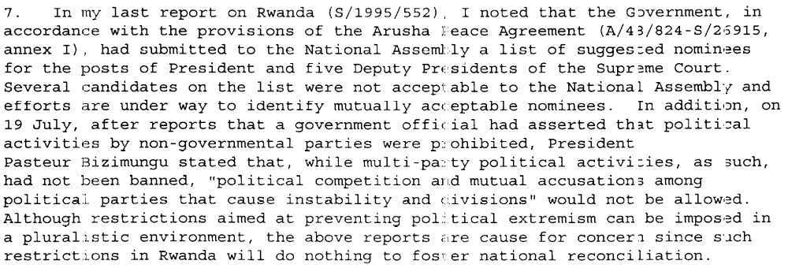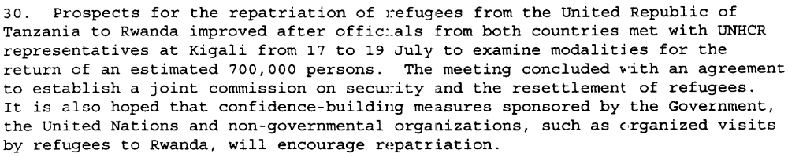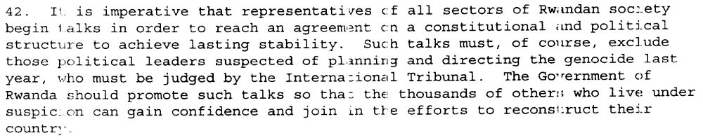
(Progress Report of the Secretary-General on the United Nations Assistance Mission for Rwanda, UN Doc. S/1995/678 (8 August 1995), par. 7, 30, 42)

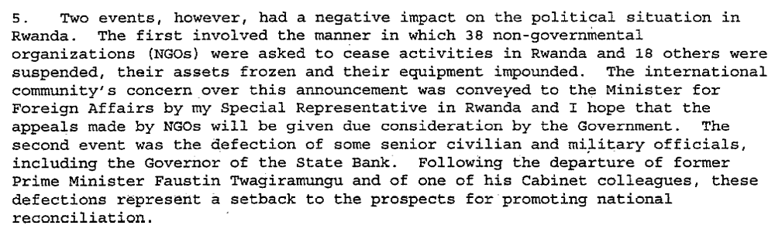
(Progress Report of the Secretary-General on the United Nations Assistance Mission for Rwanda, UN Doc. S/2996/61 (30 January 1996), par. 5)

Assessment

Medium-term compliance
No or marginal compliance (1) | Medium low compliance (2) | Medium high compliance (3) | Full or almost full compliance (4)

Considerations underlying the assessment
Although the Government of Rwanda and the Rwandan Patriotic Front took measures to bring about as much political reconciliation as they felt was possible between the RPF and the non-extremist elements of the Rwandan political landscape, as time progressed, relations became strained within the government, prompting a number of key resignations.

Depth of demand

Assessment

Level of depth of demand
Low depth of demand (1) | Medium depth of demand (2) | High depth of demand (3)

Considerations underlying the assessment

Level of confidence about coding decisions

Level of confidence about coding decision
Extremely high | High | Moderate

Comments to IPI (if any)

There are several drastic swings in level of compliance dependent on the before/after genocide variable, when one party to the conflict essentially became the Government of Rwanda. As the genocide was planned and in many cases carried out by the originally named Government of Rwanda, compliance is obviously low. However, the RPF-controlled, post-genocide Government of Rwanda made strong efforts to comply with UN resolutions.

Civil war in Rwanda

UNSC Resolution: | 929
Date of adoption: | 22 June 1994
Operative paragraph: | 9
Demand number: | 929.0911

Carla Winston

Wording of demand

Immediately bring an end to all killings of civilian populations in areas under their control and allow Member States cooperating with the Secretary-General to implement fully the mission set forth in paragraph 3 above

List of addressees of the demand

Interahamwe, Government of Rwanda, Rwandan Patriotic Front

Short-term compliance

Description of the addressee(s)’ conduct
3. As members of the Security Council are aware, since the cease-fire declared on 18 July 1994, the fighting in Rwanda has all but ceased. The Broad-based Government of National Unity (BBGNU), installed at Kigali on 19 July, has established control over the whole of the national territory.
(Progress report of the Secretary-General on the United Nations Assistance Mission for Rwanda, UN Doc. S/1994/1133 (6 October 1994), par. 3)

16. The presence of former RGF political leaders, military elements and militia in the Rwandese refugee camps, especially those in Zaire, have had a destabilizing effect on security in the camps and a number of violent incidents have occurred. Refugees suspected of favouring a return to Rwanda have frequently been attacked. The humanitarian agencies are reviewing how they can continue to deliver assistance in this insecure environment. There are also signs that ex-RGF troops located in the camps may be preparing to make incursions into Rwanda.
(Progress Report of the Secretary-General on the United Nations Assistance Mission for Rwanda, UN Doc. S/1994/1133 (6 October 1994), par. 16)

46. Under the coordination of the United Nations Rwanda Emergency Office, the international community adopted a policy of confidence-building in the southwest to encourage the internally displaced not to flee across the borders. At the political level, the RPA agreed not to occupy the south-west until conditions had stabilized. The timely and large-scale influx of United Nations and non-governmental organization resources, combined with the deployment of UNAMIR troops into the area, defused the situation. Some 350,000 people did cross the border into camps around Bukavu in Zaire; however, the majority remained within Rwanda.
(Progress Report of the Secretary-General on the United Nations Assistance Mission for Rwanda, UN Doc. S/1994/1133 (6 October 1994), par. 46)

60. … The first priority remains the resolution of the massive humanitarian crisis, including the problems faced by the Rwandese
refugees in Zaire and the United Republic of Tanzania. Acts of intimidation and violence within the refugee camps have inhibited the refugee population from choosing to return home. The Government is engaged in efforts to find a solution to these problems, with the support of United Nations agencies and programmes on the ground, coordinated by my Special Representative. Determined efforts will have to be made by the Government to create conditions under which the refugees and displaced persons can return to their homes in safety and dignity. Indeed, without the assurance that their human rights will be respected, it is unlikely that the refugees and displaced persons will return. In this regard, I have conveyed to the Government of Rwanda, through my Special Representative, the need to undertake broader efforts towards national reconciliation. I am encouraged that the Government has taken concrete steps in this direction and I urge the international community to support its efforts and encourage it to ensure that these efforts are both genuine and comprehensive.
(Progress Report of the Secretary-General on the United Nations Assistance Mission for Rwanda, UN Doc. S/1994/1133 (6 October 1994), par. 60)

7. The former Rwandese political leaders, Rwandese government forces soldiers and militia control the camps, though the degree of control varies from area to area. They are determined to ensure by force, if necessary, that the refugees do not repatriate to Rwanda. They also make it difficult for relief agencies to carry out their work in safety, because they attempt to control the agencies’ activities in the camps and prevent relief supplies from reaching those in need. It is believed that these elements may be preparing for an armed invasion of Rwanda and that they may be stockpiling and selling food distributed by relief agencies in preparation for such an invasion. There have already been some cross border incursions. Security is further undermined by general lawlessness, extortion, banditry and gang warfare between groups fighting for control of the camps. As a result of these threats to security, non-governmental organizations responsible for the distribution of relief supplies in the camps have begun to withdraw.
…
10. The militia have a significant presence in the camps in the Goma area, where they control access into and out of the camps and resort openly to intimidation and force to stop refugees who are inclined to return to Rwanda. Like the Rwandese government forces personnel, they possess firearms, as the Zairian authorities were unable to disarm all the Rwandese government forces and militia personnel when they sought refuge in Zaire in July 1994. They also possess vehicles and communication equipment.
(Report of the Secretary-General on Security in the Rwandese Refugee Camps, UN Doc. S/1994/1308 (18 November 1994), par. 7,10)

3. The Government of Rwanda has signed tripartite agreements with UNHCR and the Governments of Burundi and Zaire respectively on the voluntary repatriation of refugees. These agreements define the conditions for repatriation, including returnee protection and land tenure. The Governments of Rwanda and the United Republic of Tanzania are also involved in an ongoing dialogue on issues affecting the refugees in the latter country and their repatriation to Rwanda.
(Second Report of the Secretary-General on Security in the Rwandese Refugee Camps, UN Doc. S/1995/65 (25 January 1995), par. 3)

Assessment

Short-term compliance
No or marginal compliance (1) | Medium low compliance (2) | Medium high compliance (3) | Full or almost full compliance (4)

Considerations underlying the assessment
The Interahamwe did not cease killings of civilians in areas where it had control, but it quickly lost that control. The RPF undertook selected killings of civilians in areas under its control, but at a much smaller rate, and allowed Operation Turquoise to carry out its mission.

Medium-term compliance

Description of the addressee(s)’ conduct
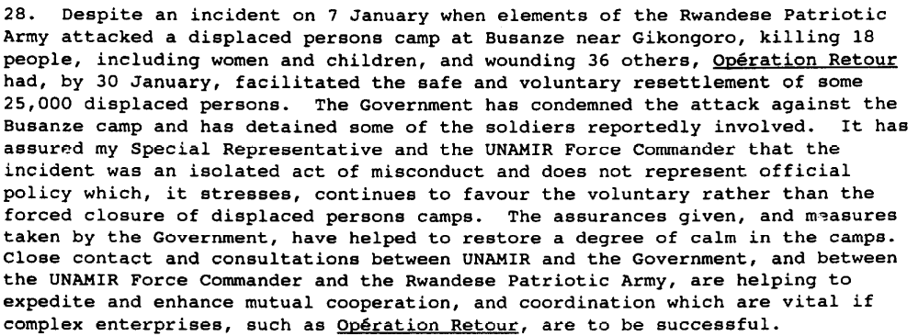
Progress Report of the Secretary-General on the United Nations Assistance Mission for Rwanda, UN Doc. S/1995/107 (6 February 1995), par. 7, 28)

Assessment

Medium-term compliance
No or marginal compliance (1) | Medium low compliance (2) | Medium high compliance (3) | Full or almost full compliance (4)

Considerations underlying the assessment

As the Interahamwe are no longer in Rwanda at this point, and are only partially in control of the refugee camps and unable to coordinate killing on a large scale, the main responsibility for compliance falls to the RPF-controlled Government of Rwanda, which is almost fully compliant in the medium term.

Depth of demand

Assessment

Level of depth of demand
Low depth of demand (1) | Medium depth of demand (2) | High depth of demand (3)

Considerations underlying the assessment
Killing civilians has nothing to do with survival as a political entity, for any party.

Level of confidence about coding decisions

Level of confidence about coding decision
Extremely high | High | Moderate

Comments to IPI (if any)

